AGC (Apollo Guidance Computer) FPGA Experiment:
5/7/2011.

Introduction:
The AGC (Apollo Guidance Computer) was a very early computer, designed in 1964, it was the first to use Integrated Circuits and the first modern embedded processor. When I was growing up, about 11 years old, I remember the Apollo program was fascinating to me and I had my eyes glued to the TV for days on end. The Moon landing made such a lasting impression on me that it is why I decided to go to engineering school and get a degree in Electrical Engineering.

Recently I saw a link to John Pultorak’s replica computer he built in tribute to the AGC. I was incredibly impressed with his accomplishment. It is built completely out of discrete TTL IC’s, all in wire wrap, more advanced than what was available in the ‘60’s but old by today’s standards. I think it was a fantastic achievement on his part and I applaud what he did. I also think I understand the retro-tech thinking on his part of using the oldest technology possible. But another retro-tech perspective is to adapt the latest technology to the old (or vice versa). I know that there are a number of efforts around Virtual AGC’s, that is emulators that run on PC’s. These are also very cool. I think a few people have messed around with an FPGA version, but I did not see a lot of work on that front. Also, I just thought it would be a fun and interesting project that would also be a learning experience.

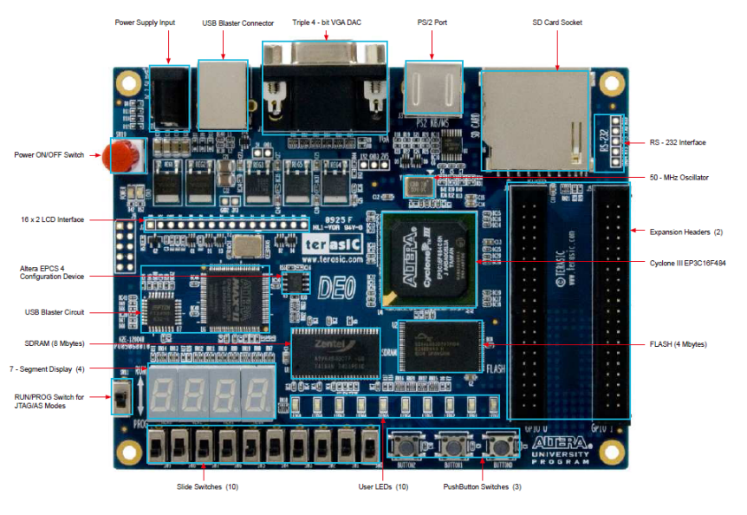
I used the Terasic DE0 FPGA (Field Programmable Gate Array) development board to experiment with. It is a Simple board, big FPGA (15KLE’s, that is 15,000 logic elements, you can think of that as the equivalent of 15,000 of the TTL chips that John Pultorak was using in his implementation all packed into a single chip that is endlessly and completely reconfigurable). The Board uses the Altera Cyclone III FPGA which has a lot of memory right on the FPGA. Having the memory built into the FPGA will simplify the initial experiment. I plan to use the on board FPGA RAM to simulate the AGC RAM and ROM. The DE0 board is nice because it is inexpensive (about $79) and it comes with a built in JTAG debugger and configuration, also it comes with the free Altera Quartus II software for development (which you can download for free from the Altera web site if you want to mess with it without even buying anything besides the board).

I have downloaded all the various MIT/NASA design documents and they are very thick. I really liked John Pultorak’s design and he has done all the heavy lifting, he has a complete Simulator and Assembler and has given away all the source code. So I based my design on his but made changes to make it work in an FPGA, but still referring to the original technical documents and specifications and where possible try to revert back to the original from the his changes when and if it makes sense.

The Top Level Design file for the Quartus project is a BDF (Block Design File) which is essentially a schematic Block diagram.

The key to the syste are the SEQ (Sequencer Module) and the CPM (Control Pulse Matrix) module. The CPM was a huge diode array in the original but for this version I am going to use un-inferred ROM. Fortunately, John Pultorak, again doing all the heavy lifting for me here, has a program that produces the ROM in HEX. I modified it because his code breaks it up into 7 separate files since the CMP-A is 56bits wide. I instantiated it in Verilog as a full 56 bit x 13 bit un-nferred RAM array. What that means is that I will tell the synthesis software to look at this as an array of bits and to reduce it for me as much as possible rather than using it’s internal RAM. What that basically means is that the Verilog compiler is going to look at the array as a Truth Table (Karnaugh map) and generate equivalent logic blocks.

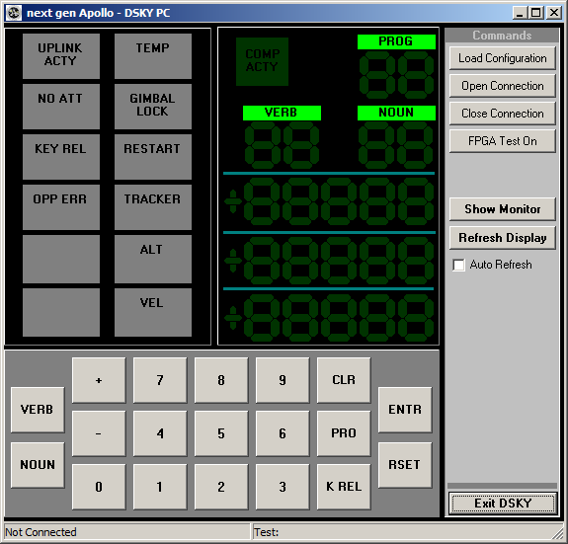
The AGC uses a very funky memory access scheme where everything to and from memory goes through 1 register, the G register. There is a very weird bit twiddling thing going on that has to do with the fact that it uses 15 bit signed numbers ( sign bit plus 14 bit magnitude) and then the 16th bit is a parity bit. Very weird. Basically the Memory both RAM and ROM are instantiated using the Altera Memory Megafunctions and just uses FPGA on board RAM to simulate it.

The ALU is super simple and is quite compact in veriolog. The Read and Write buses were replaced with a big priority mux.

The DSKY (Display Keyboard) is emulated using a program I wrote in C++. The same interface that is used in the IDE simulator I re-used and created an interface using the Altera Virtual JTAG interface. It is sort of a kludge but works OK.

I have not tested every aspect of the AGC code, but it does pass all the test and check out software.

Module Status Section:

Num Module Status
--- ------- -------------------------------------------------------------------------------
00 ng_AGC Checked Good, BDF format
01 ng_MON Checked Good, Verilog
02 ng_CLG Checked Good, Verilog
03 ng_INP Checked Good, Verilog
04 ng_DSP Checked Good, Verilog
05 ng_OUT Checked Good, Verilog
06 ng_SEQ Checked Good, Verilog
07 ng_SUB Checked Good, Verilog
08 ng_CPM Checked Good, Verilog
09 ng_ADR Checked Good, Verilog
10 ng_MEB Checked Good, Verilog
11 ng_CTR Checked Good, Verilog
12 ng_INT Checked Good, Verilog
13 ng_CRG Checked Good, Verilog
14 ng_ALU Checked Good, Verilog
15 ng_PRM Checked Good, Verilog

These units have been combined into new modules to simplify the Verilog coding for the FPGA experiment.

Num Module Status
--- ------- -------------------------------------------------------------------------------
16 ng_MEM Moved into and combined with ng_MEB, replaced MEM
17 ng_MBF Moved into and combined with ng_MEB, replaced MBF
18 ng_PAR Moved into and combined with ng_MEB, replaced PAR
19 ng_CLK Moved into and combined with ng_CLG, replaced CLK
03 ng_TPG Moved into and combined with ng_CLG, replaced TPG
04 ng_SCL Moved into and combined with ng_CLG, replaced SCL

Num Module Experiment notes:
--- ------- -------------------------------------------------------------------------------
08 ng_CPM CPMB section, fixed GTR17 negative logic error

08 ng_CPM CPMB section, fixed TPG==12, TPG==1 logoic

01 ng_MON Fixed some inverted logic, added debouncing in verilog

02 ng_CLG Combined the 2-phase clock, the Time pulse generator
and the Scaler into 1 module.

15 ng_PRM Tri-state logic does not work inside of an FPGA, decided
to use a simple priority mux instead.

08 ng_CPM Decided to use un-inferred RAM for the CPM-A section
the high degree of repetitiveness in the bit patterns should
work fine.
Tested, It assembled to about 800 LE's, not bad at all
Will look at CPM-B and CPM-C later.

10 ng_MEB Decided to combine Memory, memory buffer and parity checker
into 1 module. Bit swapping is very confusing, this could
probably be improved later, leaving as is for now.
Fixed WE selection logic
Minor change to bit shifting, I am still confused!

06 ng_SEQ There is no trickey verilog thing for the Sequencer that I can see
Will just have to brute it out with regular ole Boolean alegbra
I am not going to fiddle with this one much, it is really a nest

07 ng_SUB As far as I can tell, the only purpose that this serves is to
make some lights go on to tell you which instruction code is being
executed. I am leaving it in because if I ever decide to make
A custom PCB, it will be cool to have some flashing lights
like on the Pultorak version.

04 ng_DSP For the Display, I am not going to initially use 7 Segment display
There are 4 digits

- ng_ALU Ooopey, I have a + instead of a |, I mis-read the docs, the + means the logical
version, the OR, not addition.

- ng_CRG Found bug with the LP Register instantiation. Typo on the Bit 14 control,
should be a ”!” not a ”&”

Notes:
--------------------------------------------------------------------------------------------
1) 74LS273 clocks on positive clock edge per datasheet

2) 74LS112 clocks on negative clock edge per datasheet
Late breaking news flash for a dummy like me, the 74LS112 is a Master slave JK Flip Flop.
After doing a little research on line and googling JK flip flops, I discover that Master
Slave means that there are really 2 registers, the first one loads the input lines on the
Positive edge of the clock, then it processes the inputs and transfers the result to the
Output pins on the negative edge of the clock. This will take a little re-write, see below

3) 74LS161 clocks on positive clock edge per datasheet

4) Found out that a JK Flip Flop can be instantiated using
the following verilog code:
always@(negedge CLK or negedge CLN or negedge PRN)
if (!CLN) Q <= 0;
else if(!PRN) Q <= 1;
else Q <= ~Q & J | Q & ~K;

Based on the news flash above, the actual verilog to instantiate a Master Slave JK FF
Is as follows:

reg Q_i, Q; // Instantiate internal and output registers
always@(posedge CLK or negedge CLN or negedge PRN)
if (!CLN) Q <= 0;
else if(!PRN) Q <= 1;
else Q <= ~Q & J | Q & ~K;
always@(negedge CLK or negedge CLN or negedge PRN) Q <= Q_i;

